# Electronic photo album

## 0.96 inch monochrome OLED screen

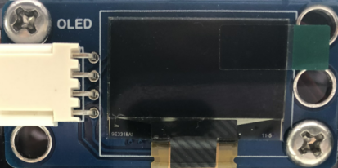

**OLED screen:** Display screen is the most commonly used module for the frequently-used devices for modern people, such as mobile phones, computers, televisions, etc. An electronic device will look backward without a display screen. The display screen really makes the interaction between electronic devices and people intuitive, simple and practical.

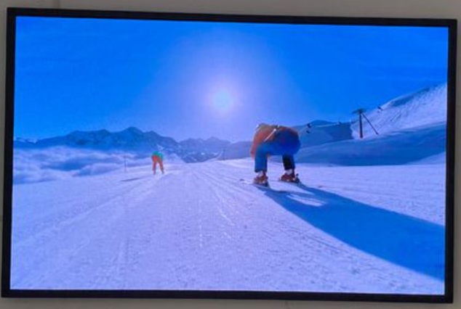

## Install the electronic photo album

|  |  |
| --- | --- |
| Remove the red part of the picture below from the infrared signal receiver of the last lesson  拆下红外信号接收器红色部分 | The remaining structure is shown in the following figure  拆完后 |
| 电子相册_空白视图 8 | 电子相册_空白视图 8_1 |
| 电子相册_空白视图 8_2 | 电子相册_空白视图 8_3 |
| 电子相册_空白视图 8_4 | 电子相册_空白视图 8_5 |
| 电子相册_空白视图 8_6 | 电子相册_空白视图 8_7 |
| 电子相册_空白视图 8_8 | 电子相册_空白视图 8_9 |
| 电子相册_空白视图 8_10 | 电子相册_空白视图 8_11 |
| 电子相册_空白视图 8_12 | 电子相册_空白视图 8_13 |
| 电子相册_空白视图 8_14 | 电子相册_空白视图 8_15 |
| 电子相册_空白视图 8_16 | 电子相册_空白视图 8_17 |
| Wiring diagram | |

## OLED displays character string

1. **Add OLED display plug-in**

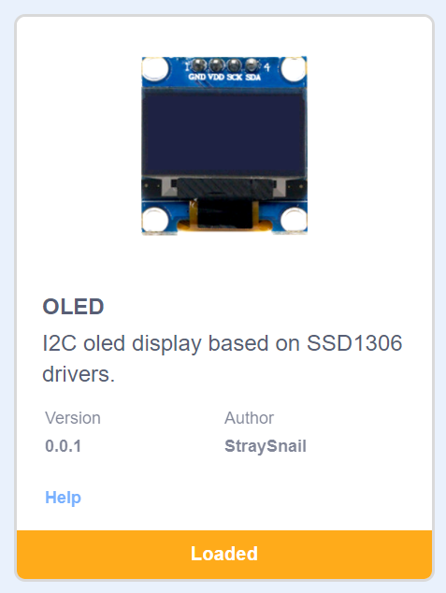

1. **Program block**

Initialize the OLED screen and set the pixel values of width and height. Our screen is 128 \* 64, and IIC communication address is 0X3C.

Clear the screen.

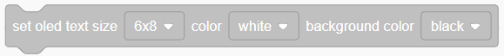Set the size and color of font.

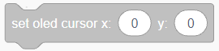Set the cursor, that is, the starting display position. 0,0 is the upper left corner.

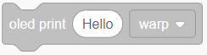OLED displays a string. You can choose to wrap or not.

Refresh the display.

1. **Example program**

|  |
| --- |
|  |

1. **Experiment phenomenon**

The OLED screen shows the string we set.

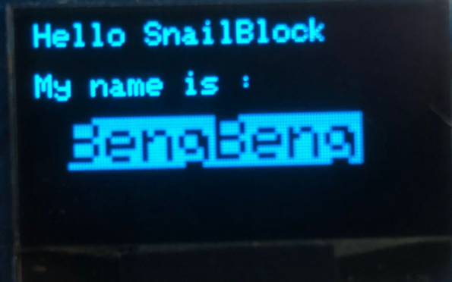

## OLED screen draws a picture

1. **Example program**

|  |
| --- |
|  |

1. **Experiment phenomenon**

|  |  |  |  |  |
| --- | --- | --- | --- | --- |
|  |  |  |  |  |

## OLED displays a pattern

As a screen, it should be able to display pictures. Now let's learn how to display pictures with OLED.

**（1）Get your pictures ready**

Our OLED pixels are 128 \* 64px, so we need to prepare 128 \* 64px pictures. We have provided sample pictures in “Sample pictures” folder.

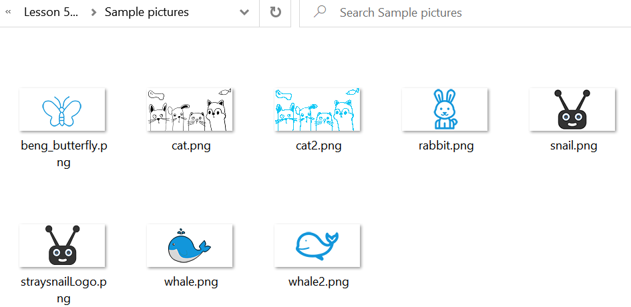

**（2）Convert the picture to hexadecimal**

Link for picture to hexadecimal:

[https://diyusthad.com/image2cpp](https://diyusthad.com/image2cpp" \t "_blank)

Open the link, and drag the “cat.png” sample picture to the “Select file”.

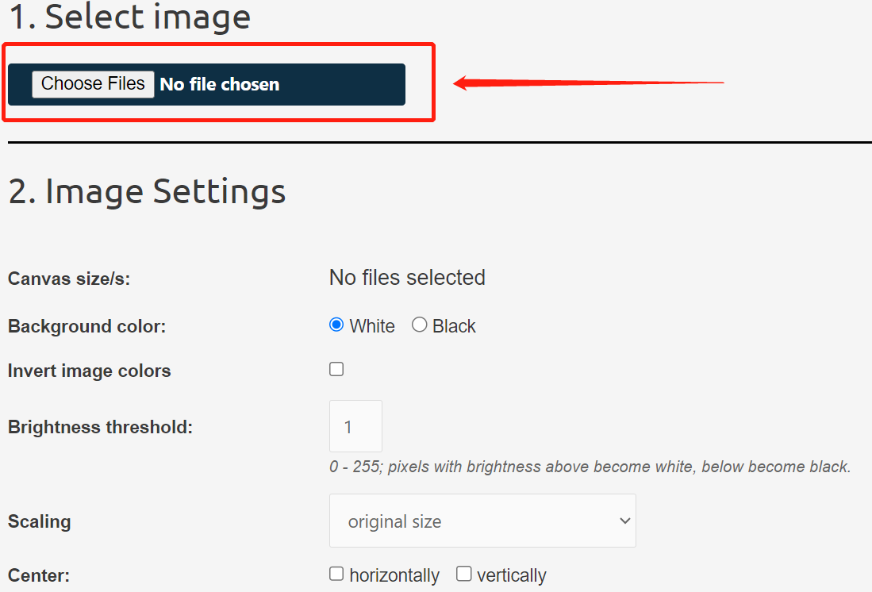



When you just bring in the picture, you can see that the effect picture in “3. Preview” is not very clear. You can click the up arrow of Brightness threshold to adjust it until the picture becomes clear, as shown below.

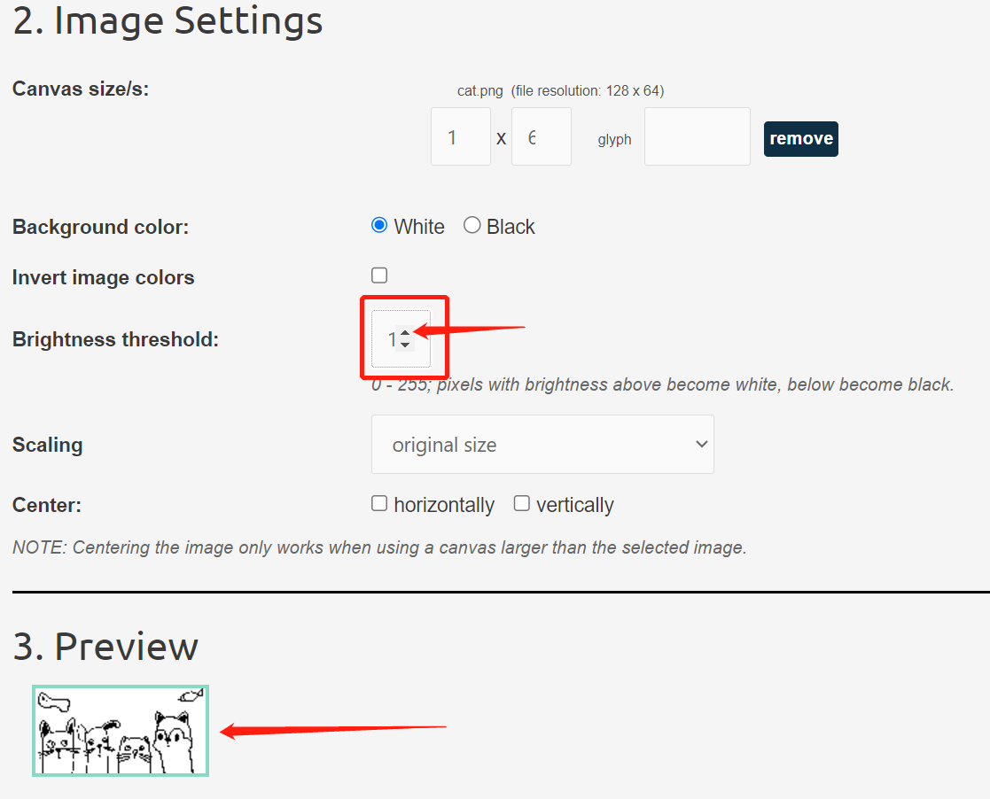

Select “Arduino code”, rename it “cat”, and then click “Generate code” to generate the hexadecimal code that adapts to Arduino C.

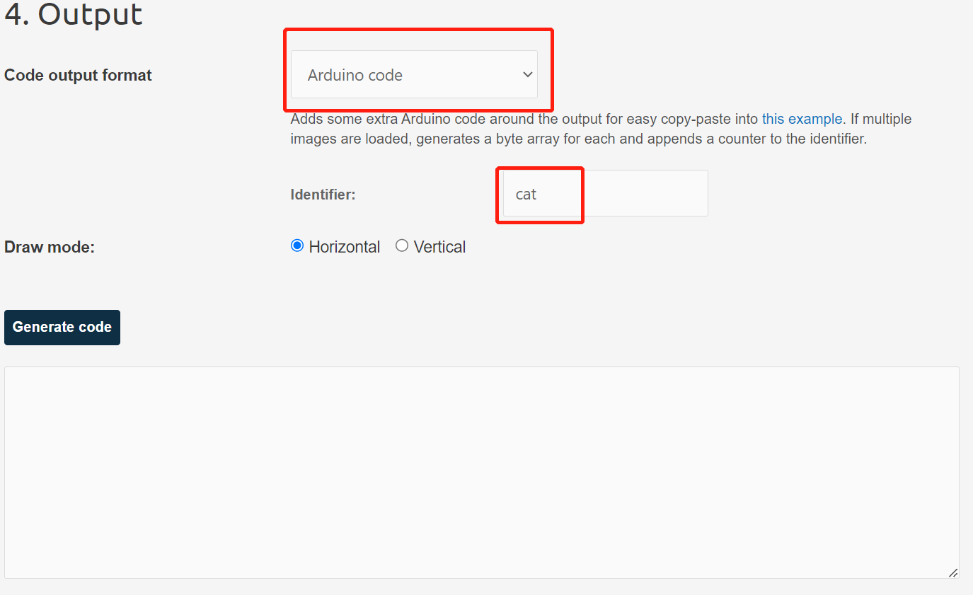

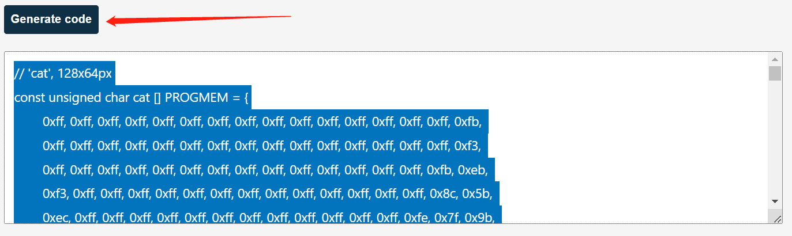

Copy the hexadecimal code (the part selected in blue in the figure above). Be careful not to copy the ending symbol "};" into it.

Paste the copied code into the data box in the OLED setting picture box, as shown below

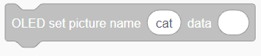



1. **Example program**

|  |
| --- |
|  |

1. **Experiment phenomenon**

The OLED screen displays the picture successfully.

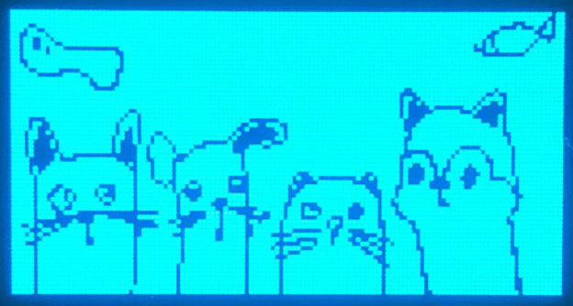

**Tips:**

Because the performance of OLED screen is not very high, it is easy to get stuck when full screen is displayed. We can set the pattern to remove the background.

To select a picture without background, as shown below.

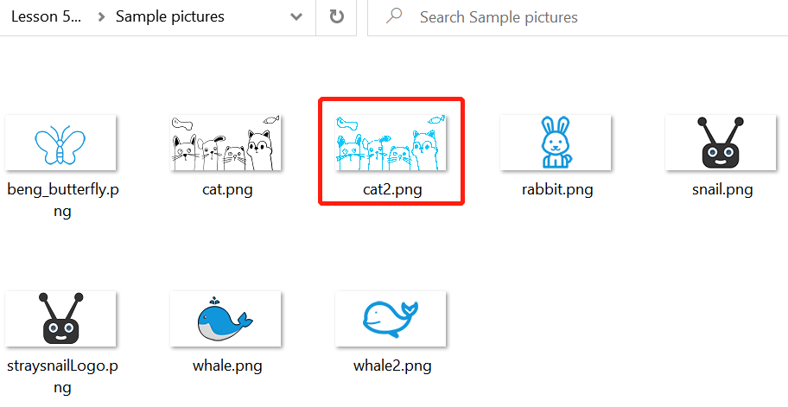

Operation:

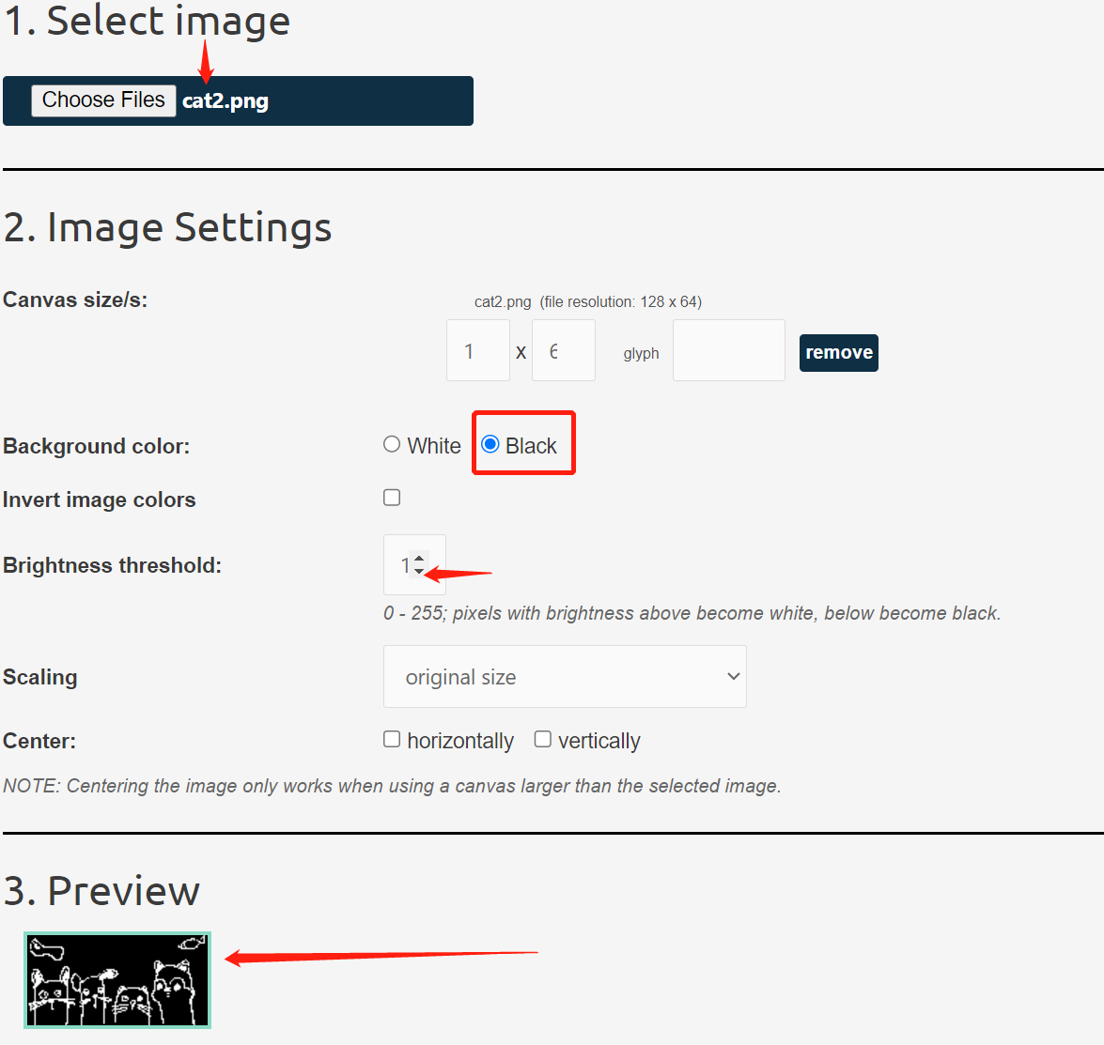

In the same way, copy the converted image code into the setting picture data program box.



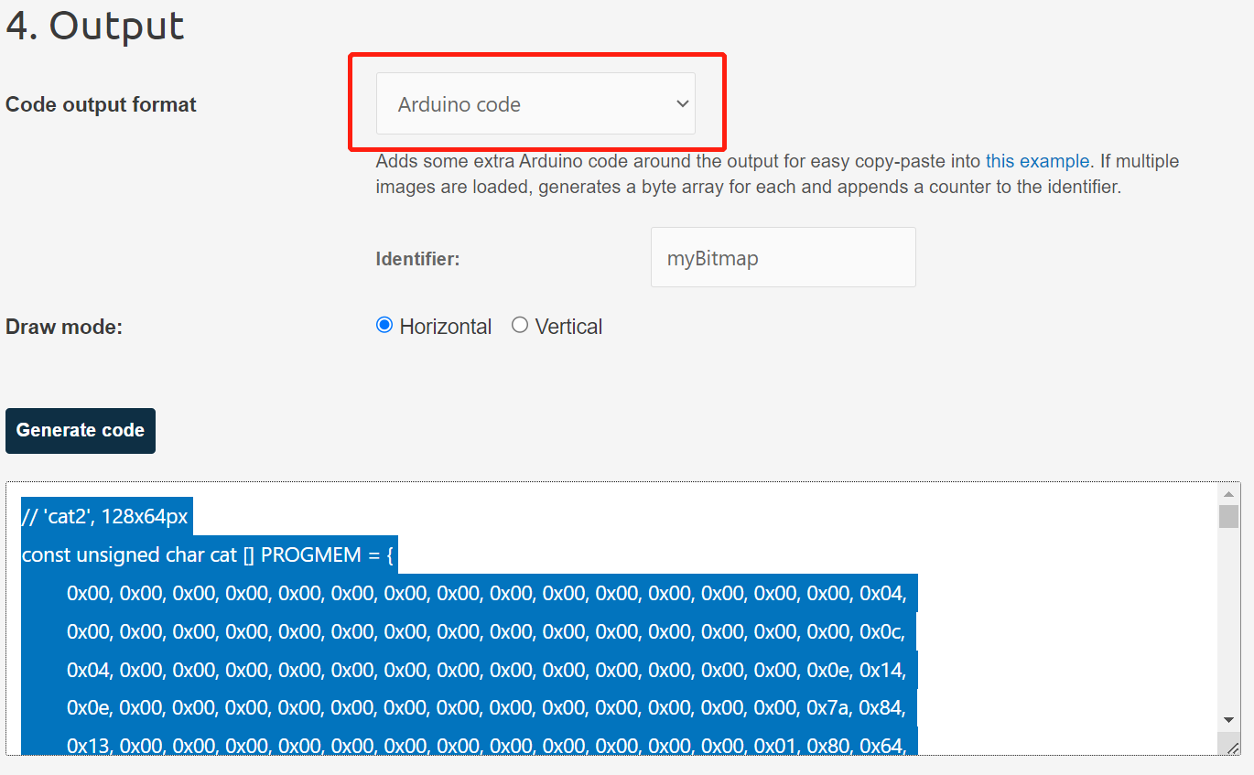

Experiment phenomenon:

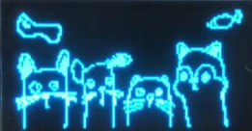

## Switch to display multiple pictures

1. **Example program**

|  |
| --- |
|  |

1. **Experiment phenomenon**

Show the following picture twice.

Note: If you can't switch pictures, please unplug the USB data cable and turn on the power switch again.

|  |  |  |  |  |
| --- | --- | --- | --- | --- |
|  |  |  |  |  |

## Make electronic photo album

We make a simple electronic photo album, and use two buttons to control and switch the pictures displayed by OLED.

1. **Program block**

**Make your own block**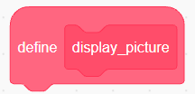: Click the self-made block, and then click to create a new block, as shown below.

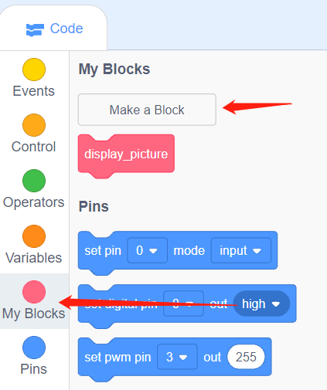

Then enter the name of the block and click “Finish”.

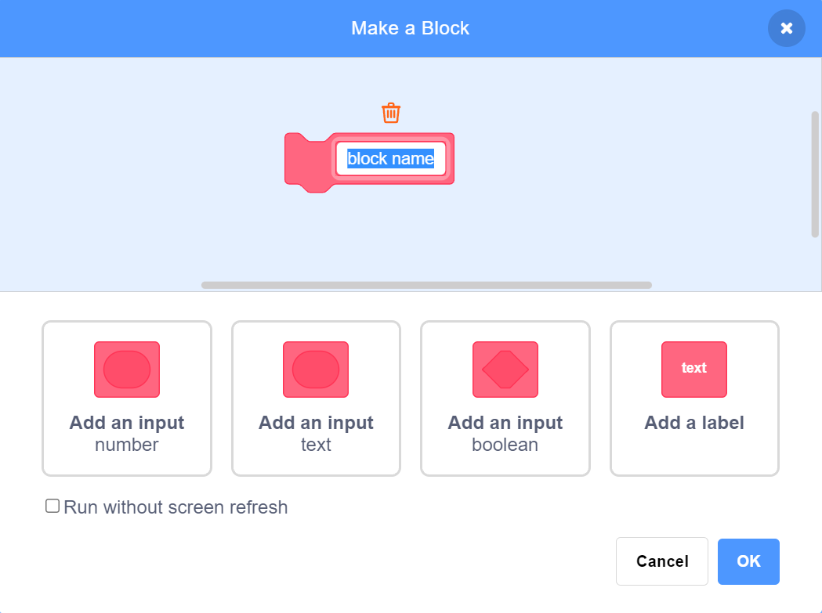

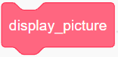Execute the program under the corresponding name block.

1. **Example program**

|  |
| --- |
|  |

1. **Experiment operation and phenomenon**

Click the two buttons to switch the pictures displayed by OLED.

|  |  |  |  |  |
| --- | --- | --- | --- | --- |
|  |  |  |  |  |